Lecture Note-03

Complex Integration

Line integral in the complex plane
Complex definite integrals are called (complex) line integrals. They are written as
.
Here the integrand is integrated over a given curve C. This curve C in the complex plane is
called the path of integration.
If C is a closed path (one whose terminal point coincides with its initial point),
then it is denoted by .
Partitioning of path C: If C is a combination of C1 and C2 then,
We may represent C by a parametric representation . That is, . The sense of increasing t is called the positive sense on C.
Note: Parametric representation of any curve is not unique.
Example 1: Find and sketch the path whose orientation is given by $z\left(t\right)=\left(1+3i\right)t (1≤t≤2)$.
Solution:  $$z\left(t\right)=\left(1+3i\right)t (1≤t≤2)$$  $$x\left(t\right)+i y\left(t\right)=t+i 3t$$  Comparing real and imaginary part, we get $x\left(t\right)=t$ , $y\left(t\right)= 3t$ $(1≤t≤2)$.  $$t$$ x y (x,y)  1 1 3 (1,3)  2 2 6 (2,6)  So, $z\left(t\right)=\left(1+3i\right)t (1≤t≤2)$ represents the line segment from (1,3) to (2,6) in complex plane. | 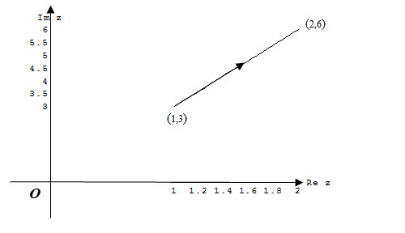  Fig: 1

Example 2: Find and sketch the path whose orientation is given by $z\left(t\right)={2e}^{it} (0≤t<π)$.
Solution:  $z\left(t\right)={2e}^{it} (0≤t<π)$  $x\left(t\right)+i y\left(t\right)=2 cos{(t)}+i2 sin{(t)}$  Comparing real and imaginary part,  we get $x\left(t\right)=2 cos⁡(t)$ , $y\left(t\right)=2 sin\left(t\right)$ $(0≤t<π)$.  So, $z\left(t\right)={2e}^{it} (0≤t<π)$ represents upper semicircle of radius 2 with center (0,0). | 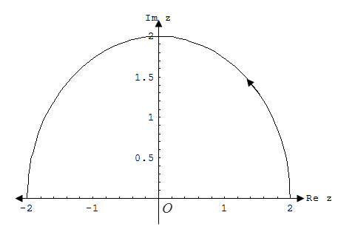  Fig: 2

Example 3: Sketch and represent the line segment from $1+i$ to $4-2i$ parametrically.
Solution:  The equation of straight line passing through the points (1,1) to (4,-2) is, $y-1=\left(\frac{-2-1}{ 4-1}\right)(x-1)$  That is, $y=-x+2$  Let, $x=t$ then $y=-t+2$ where t varies from $t=1$ to $t=4$.  So, the parametric equation of line segment from $1+i$ to $4-2i$ is,  $x\left(t\right)=t$ , $y\left(t\right)=-t+2$ $(1≤t≤4)$. | 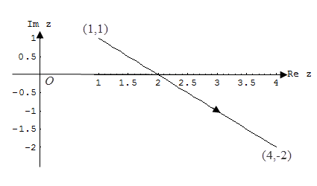  Fig: 3

Example 4: Sketch and represent unit circle (counterclockwise) parametrically.
Solution:  unit circle (counterclockwise)  That is, $\left|z\right|=1$ (counterclockwise)  Or, $\left|x+i y\right|=1⇒\sqrt{x^{2}+y^{2}}=1⇒x^{2}+y^{2}=1$ .  Let, $x=\cos{t}$ and $y=\sin{t}$,  Then ${(\cos{t})}^{2}+{(\sin{t})}^{2}=1$ where  t varies from $t=0$ to $t=2π$.  So, the parametric equation of unit circle (counterclockwise) is,  $x\left(t\right)=\cos{t}$ , $y\left(t\right)=\sin{t}$ $(0≤t<2π)$. | 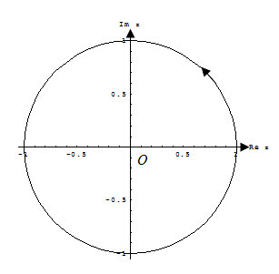  Fig: 4

Example 5: Sketch the path C consisting of two line segments, one from z = 0 to z = 2 and other from z = 2 to z = 3+i , hence evaluate, if f(z) = z².
Solution:  Given, C consists of two line segments, one from  z = 0 to z = 2 and other from z = 2 to z = 3+i.  Along $C1:$  Equation of the line, which passes through $(0,0)$ and$(2,0)$, is $y=0$  $f\left(z\right)= z^{2}={(x+iy)}^{2}=x^{2}$ [using$y=0$]  We know,$z=x+iy=x$, $dz=dx$  and $x$ varies from $0$to $2$  = $\int_{0}^{2}{x^{2}dx= \frac{8}{3}}$ . | 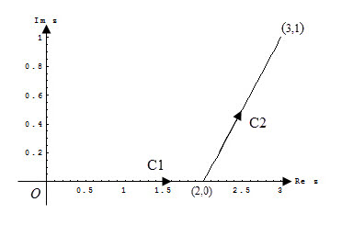  Fig: 5
Along $C2:$
Equation of the line, which passes through $(2,0)$ and$(3,1)$ is,
$$y-0=\left(\frac{1-0}{3-2}\right)\left(x-2\right)⟹y=x-2.$$
$f\left(z\right)= z^{2}={{(x+iy)}^{2}=[(y+2)+iy]}^{2}$ [using$x=y+2$]
We know,$z=x+iy=y+2+iy, dz=(1+i)dy$ and $y$ varies from $0$to $1$.
=$\int_{0}^{1}{{\left[\left(y+2\right)+iy\right]}^{2}(1+i) dy=i\int_{0}^{1}{\left(4+4i-2y^{2}+2iy^{2}+8iy\right)dy}}=\frac{10}{3}+\frac{26}{3}i$
Now, + =$6+\frac{26}{3}i$.
Example 6. Sketch the path C from $z = 0$ to $z = 4+2i$ along the curve and hence evaluate, where
Solution:  Given, $z = 0$ to $z = 4+2i$ and .  and  Now,  and | 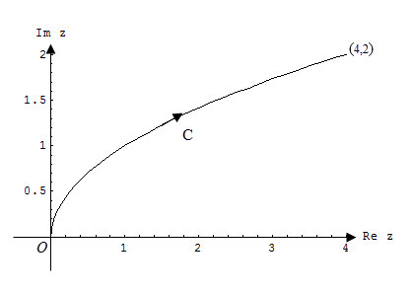  Fig: 6
Therefore,
.

Example 7: Sketch the path C from $z=-1-i$ to $z=1+i$ along the curve and hence evaluate ,where
Solution:  Given, C is the arc from $z=-1-i$ to $z=1+i$ along the curve.  and, $z=x+iy$ $=x+i$, $dz=\left(1+3x^{2}i\right)dx$  Now, =+  $=\int_{-1}^{0}{2.\left(1+3x^{2}i\right)dx+\int_{0}^{1}{x^{3}\left(1+3x^{2}i\right)dx}}$  $=\frac{9}{4}+\frac{5}{2}i$. | 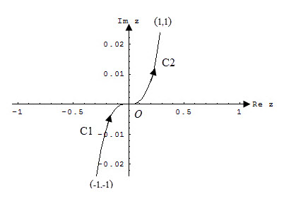  Fig: 7

Example 8: Sketch the path C from $z=-1$ to $z=1$ along the upper half of the circle and hence evaluate , where .
Solution:  Given, C is the upper half of the circle from z = -1 to z = 1.  $z=1.e^{iѲ}$, $dz=ie^{iѲ}d$, where  varies from $π$ to $0$, and = $e^{-i}$  Now, = $\int_{π}^{0}{e^{-i}}ie^{i}d= -πi$. | 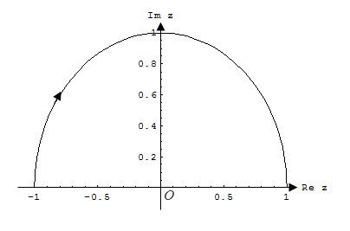  Fig: 8

Matlab command to evaluate line integrals:
- Evaluate $\int_{C}{Re \left(z\right)dz}$, where C is the shortest path from 0 to 1+2i along $z\left(t\right)=t+2it, 0≤t≤1.$  >> fun=@(z) real(z);  >> q=integral(fun,0,1+2i)  q = 0.5000 + 1.0000i | - Evaluate $\int_{C}{Re \left(z\right)dz}$, where C consists of the shortest path from z= 0 to z=1 and then to z=1+2i $.$  >> fun=@(z) real(z);  >> q=integral(fun, 0,1+2i,'Waypoints',1)  q = 0.5000 + 2.0000i
- Evaluate $\int_{C}{\overline{z} dz}$, where C is the line segment from z=2 to z=2+3i .
>> fun=@(z) conj(z);
>> q=integral(fun,2,2+3i)
q = 4.5000 + 6.0000i

Sample Exercise Set on Line Integral: 3
Sample Exercise
1. Find and sketch the path and its orientation. Also classify whether the indicated points are interior, exterior or boundary of the following curves-(vi):
(i) $z\left(t\right)=\left(1+3i\right)t (1≤t≤4)$ (iii) $z\left(t\right)={3e}^{it} (0≤t≤π)$
(ii) $z\left(t\right)=\left(2-i\right)t (-2≤t≤2)$
(iv) $z\left(t\right)={5e}^{-it} \left(0≤t≤\frac{π}{2}\right)$
(v) $z\left(t\right)=6\sin\left(t\right)+i 4\cos{(t)}\left(0≤t≤2π\right)$; (5,1)
(vi) $z\left(t\right)=2\cos\left(t\right)+i \sin\left(t\right) \left(0≤t≤2π\right); \left(6, 5\right)$
(vii) $z\left(t\right)=1+i+e^{-πit}$ $\left(0≤t≤2\right)$
(viii) $z\left(t\right)=3+4i+\left(5 cosh{t+2 i\sinh{t}}\right).$
2. Sketch and represent them parametrically. Also classify whether the indicated points are interior, exterior or boundary of the following curves-(iii & iv):
(i) Line segment from $-1+2i$ to $4-2i$ , (ii) unit circle: $\left|z\right|=1$ (clockwise)
(iii) $\left|z-4i\right|=3$ (counter clockwise) ; (1,6) (iv) $\left|z-5+i\right|=4$ (counter clock wise) ; (1,2)
3. Sketch the path $C$ from $z=0$ to $z=3i$ and hence evaluate $\int_{C}{ z^{2} dz}$ .
4. Sketch the path $C$ from $z=0$ to $z=3$ and hence evaluate $\int_{C}{ \overline{z} dz}.$
5. Sketch the path $C$ from $z=1+i$ to $z=3+3i$ and hence evaluate $\int_{C}{ Re z dz}$.
6. $\int_{C}{\ln\left(z\right)dz}$, $C$ is the shortest path from $i$ to $2i$.
7. Sketch the path $C,$ which is the circle $\left|z\right|=2$ and hence evaluate $\int_{C}{ (z+z^{-1} )dz}$.
- Sketch the corresponding paths and hence evaluate them (8-11):
8. $\int_{C}{{(e}^{2z}+\cos{z) dz}}$, $C$ is the shortest path from $z=2$to $z=4$ .
9.$\int_{C}{(z .\overline{z}) dz}$, C is the path around the square with vertices .
10. $\int_{C}{ \left( \frac{5}{z-2i}- \frac{6}{{\left(z-2i\right)}^{2 }}\right)dz}$ ,$C$ is the circle $\left|z-2i\right|=4$ , clockwise

Reference Book: Advanced Engineering Mathematics (10th edition) by Erwin Kreyszig, Herbert Kreyszig, Edward J. Norminton, published by John Wiley & Sons, Inc

